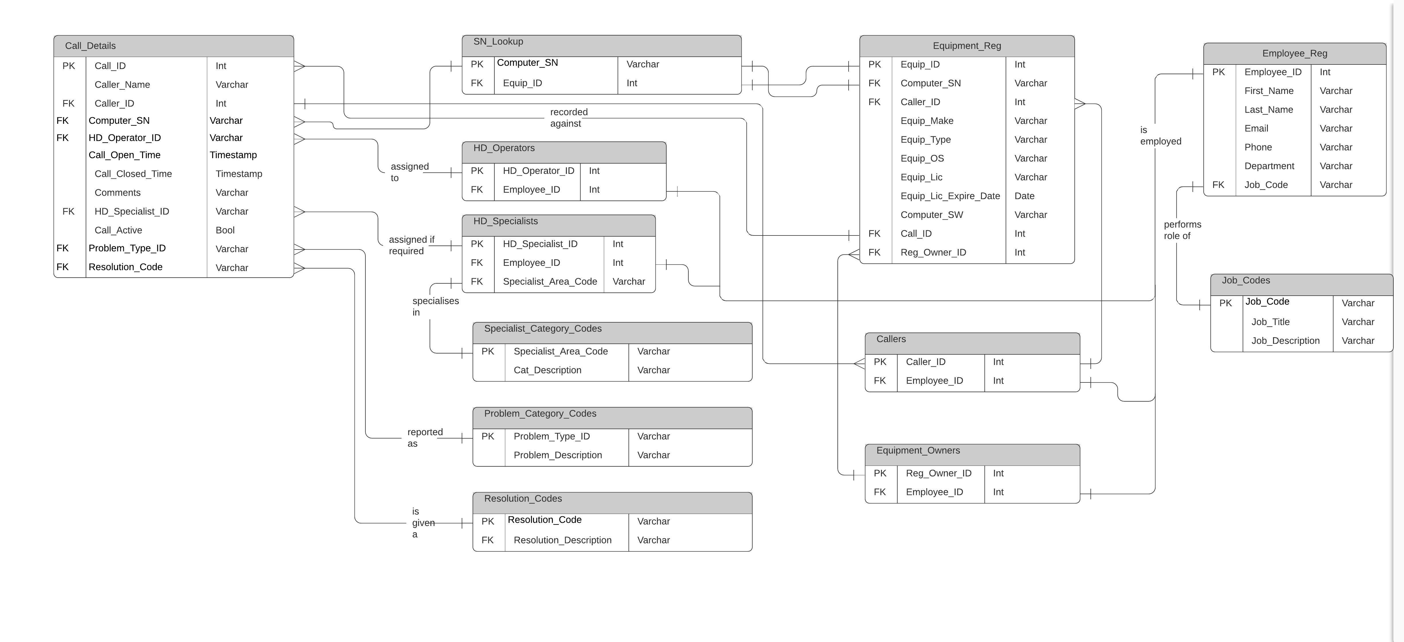CON705 Assignment 1 – Entity Relationship Diagram Help Desk Scenario.

CON705 Assignment 1 – Relational Schema – Helpdesk.

**Entities.**

**Call_Details**

The Call_Details entity is used to create a searchable record using Call_ID as a primary key. A Call_ID record would be created for every new call query automatically in the front end application and the Call_Open_Time field set to the current time. When a call is resolved Call_Active would be set from Yes to No, this would trigger the current time to populate the Call_Closed_Time field.

As the open and closed times are recorded it is not necessary to add a separate ‘time to resolve field’. This can be calculated by subtracting Call_Closed_Time and Call_Open_Time attributes.

It is possible that someone is not available to work on the call for all of the time between opening and closing the call and so it is not a true reflection of number man hours but instead the time the problem existed and took to resolve once reported. This may be a better metric from a user point of view. This is an assumption however.

|  |  |  |  |  |  |  |  |  |
| --- | --- | --- | --- | --- | --- | --- | --- | --- |
| **Column Number** | **Column**  **Name** | **Table Name** | **Type** | **Allow Nulls** | **Length** | **Constraint** | **Key Type** | **Description** |
| 1 | Call_ID | Call_details | Integer | N | 8 | Not Null | **Primary Key** | Call_ID created. |
| 2 | Caller_Name | Call_details | Varchar | N | 15 | Not Null |  | Recorded as |
| 3 | Caller_ID | Call_details | Integer | N | 8 | Not Null |  | Caller Employee_ID |
| 4 | Computer_SN | Call_details | Varchar | N | 30 | Not Null | Foreign Key (SN_Lookup) |  |
| 5 | HD_Operator_ID | Call_details | Integer | N | 6 | Not Null | Foreign Key (HD_Operators) | Assumed that HD_Operator_ID when trained.  Note: Not Employee_ID |
| 6 | Call_Open_Time | Call_details | Timestamp | N | 22 | Year, Month, Date, Hour, Minute, Second |  | The time of opening the call. |
| 7 | Call_Closed_Time | Call_details | Timestamp | Y | 22 | Year, Month, Date, Hour, Minute, Second |  | Timestamp updated when Call_active sets to No. |
| 8 | Comments | Call_details | Varchar | N | 32767 |  |  | Comments can be appended to anytime to report call progress. |
| 9 | HD_Specialist_ID | Call_details | Integer | Y | 4 | Null if resolved by HD_Operator | Foreign Key (HD_specialist) | Assumed that HD_Specialist_ID when trained.  Note: Not Employee_ID |
| 10 | Call_Active | Call_details | Boolean | N | 1 | Default No. |  | Set to No when call problem resolved. |
| 11 | Problem_ID | Call_details | Varchar | N | 8 | Not Null | Foreign Key (Problem_Category_Codes) |  |

**SN_Lookup**

The purpose of this table is to remove possibility where a a piece of equipment's serial number is present on two different computer manufacturers and so uses Equip_ID as a unique attribute.

|  |  |  |  |  |  |  |  |  |
| --- | --- | --- | --- | --- | --- | --- | --- | --- |
| **Column Number** | **Column**  **Name** | **Table Name** | **Type** | **Allow Nulls** | **Length** | **Constraint** | **Key Type** | **Description** |
| 1 | Computer_SN | SN_lookup | Varchar | N | 30 | Not Null | **Primary Key** |  |
| 2 | Equip_ID | SN_lookup | Integer | N | 8 | Not Null | Foreign Key (Equipment_Reg) |  |

**HD_Operators**

This purpose of this table is to allow any employee (i.e. specialist) to become a Helpdesk operator.

|  |  |  |  |  |  |  |  |  |
| --- | --- | --- | --- | --- | --- | --- | --- | --- |
| **Column Number** | **Column**  **Name** | **Table Name** | **Type** | **Allow Nulls** | **Length** | **Constraint** | **Key Type** | **Description** |
| 1 | HD_Operator_ID | HD_operators | Varchar | N | 6 | Not Null | **Primary Key** |  |
| 2 | Employee_ID | HD_operators | Integer | N | 8 | Not Null | Foreign Key (Employee_register) |  |

**HD_Specialists**

As above and also specialists may have multiple areas of expertise.

|  |  |  |  |  |  |  |  |  |
| --- | --- | --- | --- | --- | --- | --- | --- | --- |
| **Column Number** | **Column**  **Name** | **Table Name** | **Type** | **Allow Nulls** | **Length** | **Constraint** | **Key Type** | **Description** |
| 1 | HD_Specialist_ID | HD_specialists | Varchar | N | 60 | Not Null | **Primary Key** |  |
| 2 | Employee_ID | HD_specialists | Integer | N | 8 | Not Null | Foreign Key (Employee_register) |  |
| 3 | Specialist_Area_Code | HD_specialists | Integer | N | 6 | Not Null.  GEN to indicate general problem. | Foreign Key (Specialist_category_codes) | Code for each area of expertise. |

**Specialist_Category_Codes**

|  |  |  |  |  |  |  |  |  |
| --- | --- | --- | --- | --- | --- | --- | --- | --- |
| **Column Number** | **Column**  **Name** | **Table Name** | **Type** | **Allow Nulls** | **Length** | **Constraint** | **Key Type** | **Description** |
| 1 | Specialist_Area_Code | Specialist_Category_Codes | Varchar | N | 6 | Not Null | **Primary Key** |  |
| 2 | Cat_Description | Specialist_Category_Codes | Integer | N | 4 | Not Null |  |  |

**Problem_Category_Codes**

|  |  |  |  |  |  |  |  |  |
| --- | --- | --- | --- | --- | --- | --- | --- | --- |
| **Column Number** | **Column**  **Name** | **Table Name** | **Type** | **Allow Nulls** | **Length** | **Constraint** | **Key Type** | **Description** |
| 1 | Problem_Type_ID | Problem_Category_Codes | Varchar | N | 6 | Not Null | **Primary Key** |  |
| 2 | Problem_Description | Problem_Category_Codes | Varchar | N | 256 | Not Null |  |  |

**Resolution_Codes**

|  |  |  |  |  |  |  |  |  |
| --- | --- | --- | --- | --- | --- | --- | --- | --- |
| **Column Number** | **Column**  **Name** | **Table Name** | **Type** | **Allow Nulls** | **Length** | **Constraint** | **Key Type** | **Description** |
| 1 | Resolution_Code | Resolution_Codes | Varchar | N | 6 | Not Null | **Primary Key** |  |
| 2 | Resolution_Description | Resolution_Codes | Varchar | N | 256 | Not Null |  |  |

**Equipment_Reg**

|  |  |  |  |  |  |  |  |  |
| --- | --- | --- | --- | --- | --- | --- | --- | --- |
| **Column Number** | **Column**  **Name** | **Table Name** | **Type** | **Allow Nulls** | **Length** | **Constraint** | **Key Type** | **Description** |
| 1 | Equip_ID | Equipment_Reg | Integer | N | 8 | Not Null | **Primary Key** |  |
| 2 | Computer_SN | Equipment_Reg | Varchar | N | 8 | Not Null | Foreign Key (SN_lookup) |  |
| 3 | Caller_ID | Equipment_Reg | Integer | N | 8 | Not Null | Foreign Key (Equipment_Owners) |  |
| 4 | Equip_Make | Equipment_Reg | Varchar | N | 15 | Not Null |  |  |
| 5 | Equip_Type | Equipment_Reg | Varchar | N | 8 | Not Null | Foreign Key (HD_operators) |  |
| 6 | Equip_OS | Equipment_Reg | Varchar | Y | 8 |  |  | Operating System. |
| 7 | Equip_Lic | Equipment_Reg | Varchar | Y | 64 |  |  | License Key. |
| 8 | Equip_Lic_Expire_Date | Equipment_Reg | Date | Y |  |  | Year, Month, Date, |  |
| 9 | Computer_SW | Equipment_Reg | Varchar | Y | 64 |  |  | Software application being run. |
| 10 | Call_ID | Equipment_Reg | Integer | N | 8 | Not Null | Foreign Key (Callers) |  |
| 11 | Reg_Owner_ID | Equipment_Reg | Integer | N | 8 | Not Null | Foreign Key (Equipment_Owners) |  |

**Equipment_Owners**

|  |  |  |  |  |  |  |  |  |
| --- | --- | --- | --- | --- | --- | --- | --- | --- |
| **Column Number** | **Column**  **Name** | **Table Name** | **Type** | **Allow Nulls** | **Length** | **Constraint** | **Key Type** | **Description** |
| 1 | Reg_Owner_ID | Equipment_Owners | Varchar | N | 8 | Not Null | **Primary Key** |  |
| 2 | Employee_ID | Equipment_Owners | Integer | N | 8 | Not Null | Foreign Key (Employee_Reg)) |  |

**Callers**

Callers table allows a caller who is not the registered equipment owner to query a problem.

|  |  |  |  |  |  |  |  |  |
| --- | --- | --- | --- | --- | --- | --- | --- | --- |
| **Column Number** | **Column**  **Name** | **Table Name** | **Type** | **Allow Nulls** | **Length** | **Constraint** | **Key Type** | **Description** |
| 1 | Caller_ID | Callers | Varchar | N | 8 | Not Null | **Primary Key** |  |
| 2 | Employee_ID | Callers | Integer | N | 8 | Not Null | Foreign Key (Employee_Reg)) |  |

**Employee_Reg**

|  |  |  |  |  |  |  |  |  |
| --- | --- | --- | --- | --- | --- | --- | --- | --- |
| **Column Number** | **Column**  **Name** | **Table Name** | **Type** | **Allow Nulls** | **Length** | **Constraint** | **Key Type** | **Description** |
| 1 | Employee_ID | Employee_Reg | Integer | N | 8 | Not Null | **Primary Key** |  |
| 2 | First_Name | Employee_Reg | Varchar | N | 15 | Not Null |  |  |
| 3 | Last_Name | Employee_Reg | Varchar | N | 15 | Not Null |  |  |
| 4 | Department | Employee_Reg | Varchar | N | 8 | Not Null |  |  |
| 5 | Phone | Employee_Reg | Varchar | N | 15 | Not Null |  |  |
| 6 | Email | Employee_Reg | Varchar | Y | 64 | [A@B.C](mailto:A@B.C) format |  |  |
| 7 | Job_Code | Employee_Reg | Varchar | N | 8 | Not Null | Foreign Key (Job_Codes) |  |

**Job_Codes**

|  |  |  |  |  |  |  |  |  |
| --- | --- | --- | --- | --- | --- | --- | --- | --- |
| **Column Number** | **Column**  **Name** | **Table Name** | **Type** | **Allow Nulls** | **Length** | **Constraint** | **Key Type** | **Description** |
| 1 | Job_Code | Job_Codes | Varchar | N | 8 | Not Null | **Primary Key** |  |
| 2 | Job_Description | Job_Codes | Varchar | N | 64 | Not Null |  |  |
| 3 | Job_Title | Job_Codes | Varchar | N | 64 | Not Null |  |  |